SQLLine详解

SQLLine类似于Oracle的sqlplus、MySQL的mysql，是完全基于Java的关系型数据库连接的SQL命令执行工具，与平台无关，SQLLine依赖以下软件：

* JVM，SQLLine是Java程序，运行在JDK 1.3以上版本
* Jline，SQLLine使用Jline实现控制台输入
* JDBC Driver，SQLLine使用Java数据库连接库来连接数据库，因此需要获取要访问数据库的JDBC Driver库

# 1.SQLLine的安装

下载sqlline的依赖jar包

*http://search.maven.org/remotecontent?filepath=sqlline/sqlline/1.3.0/sqlline-1.3.0-jar-with-dependencies.jar*

将sqlline及driver的jar包加载到classpath中。复制sqlline脚本到使用目录中，执行如下：

*$ sqlline -d com.mysql.jdbc.Driver*

*sqlline> !connect jdbc:mysql://localhost:3306/scott user password*

*sqlline> !tables*

*+------------+--------------+-------------+---------------+----------+*

*| TABLE_CAT | TABLE_SCHEM | TABLE_NAME | TABLE_TYPE | REMARKS |*

*+------------+--------------+-------------+---------------+----------+*

*| null | SCOTT | BONUS | TABLE | null |*

*| null | SCOTT | DEPT | TABLE | null |*

*| null | SCOTT | EMP | TABLE | null |*

*| null | SCOTT | SALGRADE | TABLE | null |*

*| null | metadata | COLUMNS | SYSTEM_TABLE | null |*

*| null | metadata | TABLES | SYSTEM_TABLE | null |*

*+------------+--------------+-------------+---------------+----------+*

*sqlline> SELECT 1 + 2 AS c;*

*+---+*

*| C |*

*+---+*

*| 3 |*

*+---+*

*sqlline> !quit*

https://github.com/julianhyde/sqlline

# 2.SQLLine执行流程

通过工程内置的sqlline脚本来执行数据库连接，调用的类为SqlLine：

*$ ./sqlline*

*sqlline>!connect jdbc:mysql://localhost:3306/scott user password*

SQLLine的类图如下所示：



执行流程图如下所示：



最终调用:

*Driver#connect(url,callback)*

Driver的初始化在DatabaseConnection#connect中

*Driver theDriver = null;*

*try {*

*theDriver = DriverManager.getDriver(url);*

*foundDriver = theDriver != null;*

*} catch (Exception e) {*

*// ignore*

*}*

DriverManager#getDriver(url)，如下所示：

*public static Driver getDriver(String url)*

*throws SQLException {*

*Class<?> callerClass = Reflection.getCallerClass();.*

*for (DriverInfo aDriver : registeredDrivers) {*

*if(isDriverAllowed(aDriver.driver, callerClass)) {*

*try {*

*if(aDriver.driver.acceptsURL(url)) {*

*return (aDriver.driver);*

*}*

*} ....*

*}*

*}*

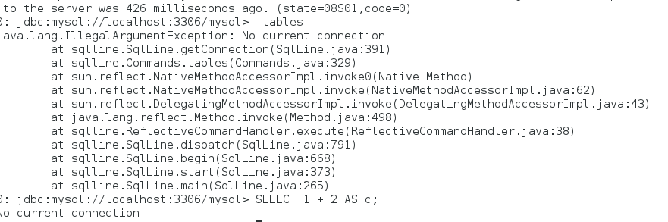

http://sqlline.sourceforge.net/#introduction

http://julianhyde.github.io/sqlline/manual.html#known_drivers

http://search.maven.org/#search%7Cga%7C1%7Csqlline

https://github.com/julianhyde/sqlline

http://julianhyde.github.io/sqlline/manual.html#usage_running